456/1

**MATHEMATICS**

PAPER 1

**April, 2024**

**2 hours 30 minutes**

**END OF TERM 1 ASSESSMENT 2024**

SENIOR FOUR

**MATHEMATICS**

PAPER ONE

**2HOURS 30 MINUTES**

**INSTRUCTIONS:**

Attempt **any five** items in this paper.

**All** items carry equal marks.

Silent non programmable calculators may be used .

Begin **each** answer on a fresh sheet of paper .

All working must be shown clearly .

**ITEM ONE**

Herman and his father Lutaaya have an age difference of **25** years and the product of their ages is **150** years . One day during a mathematics lesson Herman borrows a calculator from his neighbor and on the screen he finds a number **840** which made him wonder which two numbers he could have entered to get the answer as the product of the figures . Later on during the festive season Herman and his elder brother Tom were visited by their uncle and were each given **UGX42,000** and **UGX53,500** respectively . Herman used all his money to buy 4 shirts and 3 vests while Tom used all his money to buy 5 shirts and 4 vests .

**Task**:

1. How old do you think is Herman and his father Lutaaya. **( 5 marks)**
2. Help Herman figure out all the possible values that his neighbor could have typed in the calculator to get the number on the screen**. ( 6 marks )**
3. Help the two brothers to explain to their father how much he would spend if he wanted to buy 3 vests and 5 shirts for their cousin brother Isaac . **(4marks).**

**ITEM TWO**

Four members of Gayaza Market order for produce from Namisindwa Village and the items are as given below .

Allan bought one bag of posho , 5 bags of millet , 2 bags of sorghum and 2 bags of rice .

Bella bought 5 bags of posho , 3 bags of millet and 4 bags rice .

Cate bought 4 bags of posho and 8 bags of rice .

Dorcus bought 3 bags of rice , 4 bags of sorghum , 3 bags of millet and 2 bags of posho .

The cost per bag of the items bought was: Rice at **UGX200,000** , Sorghum at **UGX60,000,** Millet at **UGX75,000** and Posho at **UGX100,000.**

**Task:**

a) Assist the market members to summarize the above in matrix form for the :

i) Number of bags bought per item. ( 2 marks)

ii) Cost per item. ( 2 marks)

b) Using your knowledge of matrix multiplication help the members to know how each shall spend on their purchases , and hence find the total cost for all the four venders ( 5 marks)

c) If the sales for the four market venders was **UGX14.3 millions** and agreed to share the money amongst **Allan, Cate , Bella** and **Dorcus** in the ratio **2:4:6:1** respectively . Help the members to determine how each take and represent the information on a pie chart . ( 6 marks )

**ITEM THREE**

a) You have budgeted **UGX100,000** to improve your swimming over the holiday . At your local pool, it costs **UGX 50,000** to join the swim association and **UGX.5,000** for each swim class.



Write and solve an inequality to find the possible numbers of swim classes you can attend within your budget . ( 4 marks)

b) The time T seconds for the simple pendulum shown in the figure to swing to and fro is given by the formula :

**T=2π $\sqrt{(\frac{l}{g})},$**where **g m/s2** is the acceleration due to gravity.

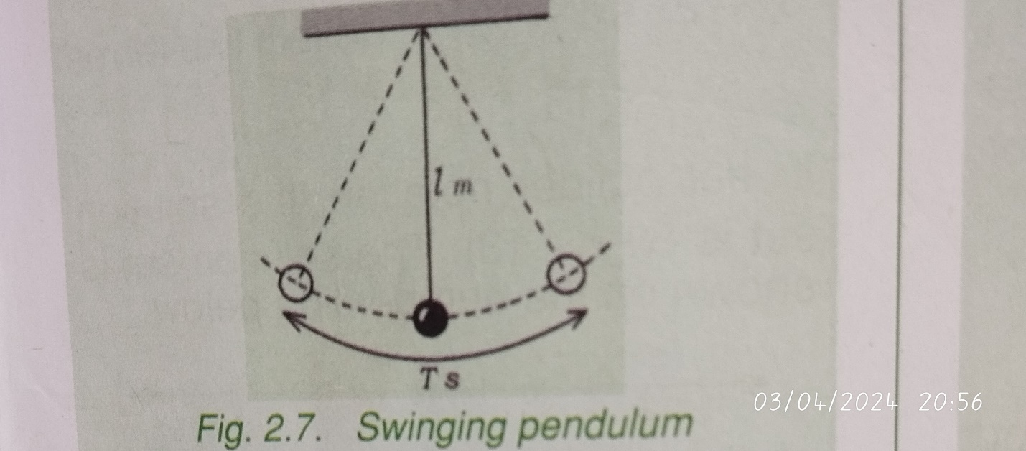

a) Make (i) **l** (ii) **g** , the subject of this formula . ( 7 marks)

b) A “seconds pendulum “ is a pendulum which swings to and fro in 1 second . Find the length of a seconds pendulum near the equator , where **g = 9.78m/s2.**

( 4 marks )

**ITEM FOUR**

Lwasa a prominent business man in Kiwenda Town wants to start Hardware in the town that is valued **UGX. 12.5 millions** . He has saved **45%** of the required amount with his local **SACCO** and wants to top up the balance . However he has been approached by two money lenders Juma and Saidi who lend their money according to the following conditions .

|  |  |
| --- | --- |
| **JUMA** | **SAIDI** |
| He lends at a simple interest rate of **8%**  Per annum payable in **24** equal monthly installments. | He lends at a compound interest of **8%** per annum payable in **24** equal monthly installments . |

Mr Lwasa wants to decide on which of the two money lenders to opt for.

**Task:**

a) Help Mr Lwasa find how much money he intends to borrow . ( 4 marks )

b) Which of the two money lenders would you recommend Mr Lwasa to opt for.

( 5 marks)

c) Having selected for Mr Lwasa the right money lender how much does he pay per installment ? ( 4 marks )

d) What will be the saving Mr Lwasa would make if he had all the money at the start than going for the loan from this money lender. ( 3 marks )

**ITEM FIVE**

A farmer needs to buy up to **25** cattle for his farm . He can buy either brown cows at **UGX. 1,200,000** each or black cows at **UGX. 1,920,000** each and he can spend a total of not more than **UGX. 38.4 million**. He must have at least **9** cows of each type . If **x** is the number of brown cows and **y** is the number black cows , write down all inequalities to represent the information . ( 5 marks )

Represent the inequalities formed above on a graph and show the feasible region and use it to determine the greatest number of cattle that can be bought to maximize the expenditure . ( 10 marks)

**ITEM SIX**

You are to participate in a Ludo game at school. Each of you was told to carry a dice that will help you to win .When you reached home, you decided to test your dice by rolling it 60 times while recording the value that appears . Below were the results of each roll you made.

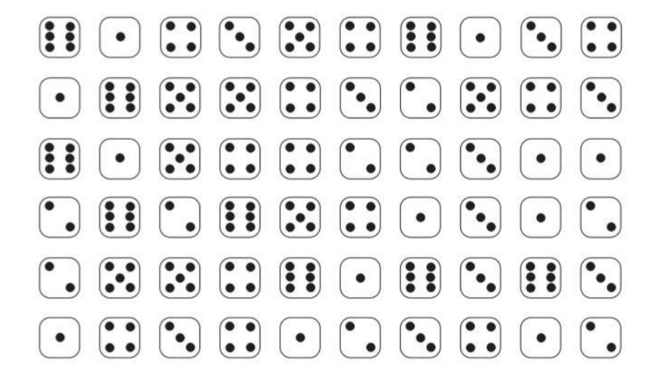

Task:

a) Summarize your scores . ( 4 marks)

b) Basing on your summary , which one is your lucky number on the dice ?

( 2 marks)

c) Odd numbers and even numbers , which of the two has the highest probability on your dice . ( 4 marks )

d) You want to show your results to one of your friends at home so that he can help to decide whether to take your dice or not . However your friend understands diagrams more than numbers . Come up with a diagram that you will show your friend . ( 5 marks)

***END***